DOCUMENT 12 — Onboarding & Personalization Spec
Visionary Internal · v1.0 · First 5 minutes = the trust contract

1. Flow with provisional fallback
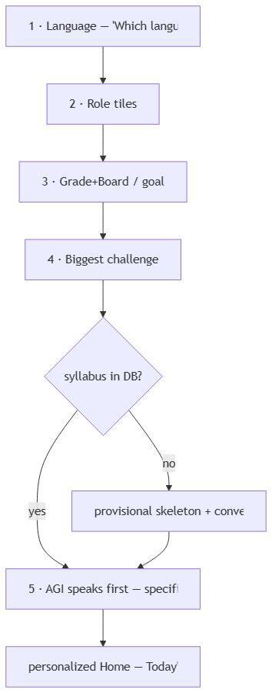

2. Screen contract

Screen | Captures | Writes | Rule
1 Language | primary_language | profile | identity, not settings; never a globe icon
2 Role | user_type | adapter | large tiles, not dropdown
3 Context | board/class/exam or goal | syllabus auto-config (L3–L7) | KG preloaded
4 Challenge | pedagogy prior | ATE prior | shapes first explanation
5 AGI-first | — | session | references board+class+challenge before user types

3. Personalization at first session
- Home shows AGI-selected next action + reason + evidence; never 0 (new topic → "let's discover your level", Fix 02).
- Memory card seeded with onboarding facts, labelled as such (not inferred weakness).
- Provisional users: conversational mode + honest "we're preparing your curriculum" card; auto-upgrade ≤7 days preserves progress (Doc 11 gap queue).
- OTP success ≥90% with guest fallback; notifications deferred to first SRS reminder.

OKF
KF1 onboarding ≤2:00 median, ≥80% completion · KF2 100% of first AGI lines reference user's own context · KF3 provisional path never blocks · KF4 OTP ≥90% with guest fallback · KF5 language badge visible from screen 1 onward.

